Taipei World Trade Center Exhibition Hall Conference Room Application Form
Valid as of 08/2023
Application for Conference Room No.: □A1 □A2 □A3 □ A4 □A5 □A+ □Hallway □VIP Room(1F)
Period (Dates/Hours) from: to:
Title of Event:
Company Name:
Invoice Mailing Address: □□□
Uniform Invoice Number: | Company President: |  | Contact Person:
Telephone Number: |  | E-mail:
Official event time: from: to:
Expected number of participants: |  | Expected number of VIPs:
List of rental equipment (no self-prepared equipment allowed)
No. | Description | Qty | Remarks
E01/E51 | Tablecloth (per table) |  | Tables free/Cloths charged
E02/E52 | Apron |  | Tables free/Apron charged
E13/E50 | Chair cover
E03/E53 | Platform (90x90x25cm)
E06/E56 | Microphone |  | Charge for more than two microphones
E12/E62 | Liquid Single Light Projector (1920*1200) |  | For video or computer projecting, screen included
E15/E65 | Laser Pointer
E07/E58 | Liquid-crystal display televisions (LCD TV) |  | 80-inch screen with stand
E22/E77 | Liquid-crystal display televisions (LCD TV) |  | 86-inch screen with stand
E19/E63 | Video matrix switcher
EAD1 | ADSL for Internet (Set up)
EAD2 | ADSL for Internet (Line Charge)
E23/E78 | Retractable Barrier

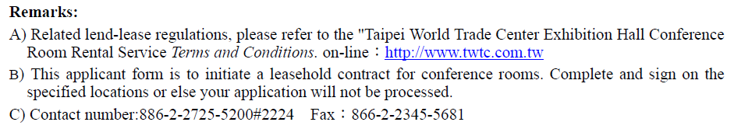

Applicant (stamped seal),  (Company seal & president's seal) | Style of Layout | Purveyor
Date:___________(MM/DD/YYYY) | Select a layout for tables and chairs:  （refer to layout charts）  □ Theater □ Standard □ Classroom  If difference form above the sketch, a simple layout below:  （Layout must be submitted to TWTC at least one week before the date of the event）

